**MINI PROJECT – II**

**(2018-19)**

# ONLINE VOTING SYSTEM

# 

**SYNOPSIS**



**Institute of Engineering & Technology**

**Team Members**

PUSHKAR KRISHNA OJHA

(171500246)

KUNAL VARSHNEY

(171500172)

SHUSHIL KUMAR PANDEY

(171500351)

## Supervised By

**Mr.VAIBHAV DIWAN**

**Asst. Professor**

**Department of Computer Engineering & Applications**

**About the Project:**

“ONLINE VOTING SYSTEM” is an online voting technique. It is based on the other online services like “ONLINE RESERVATION SYSTEM” .In this system people who have citizenship of INDIA and whose age is above 18 years of any [censored] can give his\her vote online without going to any polling booth.

In “ONLINE VOTING SYSTEM” a voter can use his\her voting right online without any difficulty. He\She has to fill a registration form to register himself\herself. All the entries is checked by the DATABASE which has already all information about the voter. If all the entries are correct then a USER ID and PASSWORD is given to the voter, by using that ID and PASSWORD he\she can use his\her vote. If conditions are wrong then that entry will be discarded.

**Statement about the problem**

Internet has led to discussion of e-democracy and online voting. Many peoples think that the internet could replace representative democracy, enabling everyone to vote on everything and anything by online voting .Online voting could reduce cost and make voting more convenient. This type of voting can be done for e-democracy, or it may be used for finalizing a solution, if many alternatives are present. Online voting make’s use of authentication, hence it needs security, and the system must be able to address obtaining, marking, delivering and counting ballots via computer. Advantage of online voting is it could increase voter turnout because of convenience, and it helps to reduce fraud voting.

**SCOPE**

A Scope survey suggested more than two thirds of the general election polling stations failed basic access tests.Ms Scott [of Scope] said the country’s voting system “isn’t working for other voters either,” demonstrated by “scores of people queuing outside polling stations” at the recent general election.

“Over the last decade there has been next to no improvement in the overall accessibility of polling stations or postal voting“There is a pressing need for clearer accountability over how elections are delivered, to help improve the accessibility of curre nt voting methods, as well as expanding these to include alternative methods.“Unless this happens disabled people will continue to struggle to exercise their right to vote“In a digital age where people can vote by text for the X-Factor and shop and bank online, our voting system really needs to catch up.”

Although Scope’s report highlights a significant problems, the proposed solution – online and text voting – would bring its own major problems. Both have been tested out in the UK in a series of pilots with mixed results. Although the pilot series was often popular with the public, it has also been unpopular with many IT security experts who doubt the security of such voting methods, the systems were often unreliable and they were far more expensive than traditional voting methods. They also did not raise turnout significantly. For a good recent summary of the case against these sorts of new voting methods.

**OBJECTIVE**

The most crucial factor for a system like e-VOTE to be successful is to exhibit a Voting Protocol that can prevent opportunities for fraud or for sacrificing the voter's privacy

The Voting Protocol that will be designed and implemented for the e-VOTE system will combine the advantages of existing protocols and techniques, while at the same time it will aim at eliminating most of the identified deficiencies and problems. The related attributes that the e-VOTE system will fully support, and against which it will be extensively tested and validated, are listed below. These attributes can be also considered, according to the literature, as a set of criteria for a "good" electronic voting system that can easily enjoy the trust and confidence of the voters and process organizers.

**FLOW CHART**

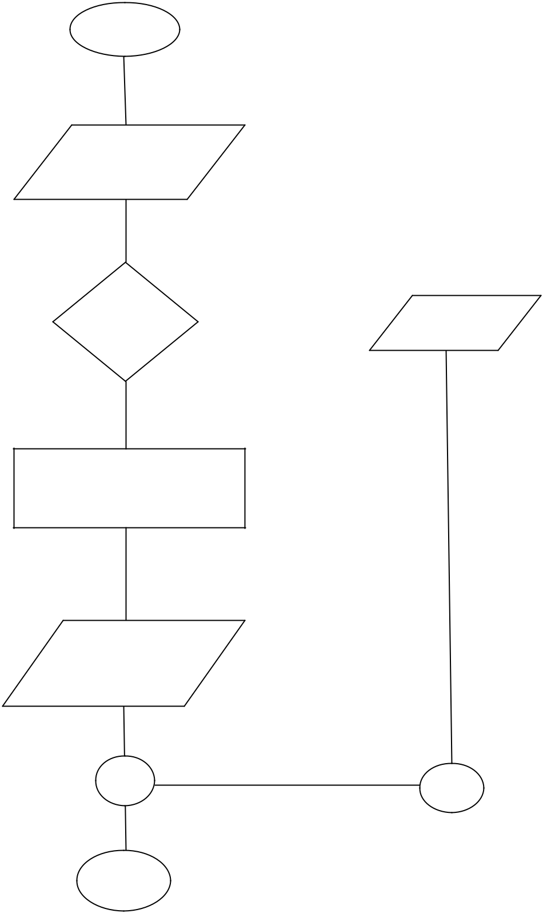

Start

Input name and

password

|  |  |  |  |
| --- | --- | --- | --- |
| If matched | False | | |
| name and |  |  | End of file |
|  |  |
| password |  |  |  |

True

Successfully comment vote and create

issue

Display the vote

comment etc

end

**E R DIAGRAM**

In [software engineering](http://en.wikipedia.org/wiki/Software_engineering), an **entity–relationship model** (**ER model**) is a [data model](http://en.wikipedia.org/wiki/Data_modeling) for describing the data or information aspects of a business domain or its process requirements, in an abstract way that lends itself to ultimately being implemented in a [database](http://en.wikipedia.org/wiki/Database) such as a [relational database](http://en.wikipedia.org/wiki/Relational_database). The main components of ER models are [entities](http://en.wikipedia.org/wiki/Entities) (things) and the relationships that can exist among them.

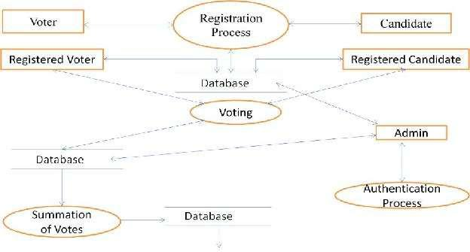

**SOFTWARE REQUIREMENTS:**

1. **MYSQL DBMS-** It allows combination, extraction, manipulation and organization of data in the voters’ database. It is platform independent and therefore can be implemented and used across several such as Windows, Linux server and is compatible with various hardware mainframes. It is fast in performance, stable and provides business value at a low cost.
2. **NetBeans IDE 7.1.2-** The NetBeans IDE is an award-winning integrated development environment available for Windows, Mac, Linux, and Solaris. The NetBeans project consists of an open-source IDE and an application platform that enable developers to rapidly create web, enterprise, desktop, and mobile applications using the Java platform, as well as PHP, JavaScript and Ajax, Groovy and Grails, and C/C++.

The NetBeans project is supported by a vibrant developer community and offers extensive documentation and training resources as well as a diverse selection of third-party plugins.

1. **JAVA coding-**This is for advanced user who find PHP codes easy to work with.
2. **Testing-** is done via WAMPSERVER.
3. **Web browsers**: Mozilla Firefox, Google chrome, Opera and Internet Explorer
4. **Reporting Tool** i.e. through Data Report.

**HARDWARE REQUIREMENTS:**

* **Microsoft Windows XP Professional SP3/Vista SP1/Windows 7 Professional:**
  + **Processor:**800MHz Intel Pentium III or equivalent
  + **Memory:**512 MB
  + **Disk space:**750 MB of free disk space
* **Ubuntu 9.10:**
  + **Processor:**800MHz Intel Pentium III or equivalent
  + **Memory:**512 MB
  + **Disk space:**650 MB of free disk space

**CONCLUSION**

Online voting system is developed by using PHP as front end and My SQL for database in back end to computerize the process for check in and out system.

This project covers only the basic required to sum up, developing a information system on “online voting system”for was a matter of essence.

**References**

[www.phptpoint.com](http://www.phptpoint.com)

[www.google.com](http://www.google.com/)

[www.php.net](http://www.php.net/)

[www.apache.org](http://www.apache.org/)

[www.mysqltutorial.org](http://www.mysqltutorial.org/)